VPN-DII configuration

January 2025 - versione 1.4

## 

1. Prerequisites 1

1.1. Supported operating systems 1

1.2. IT Services 2

2. Configuration and connection 2

2.1 Windows 2

2.2 macOS 9

3. Password change 19

3.1 Password change 19

4 HELPDESK 21

## 

## **1. Prerequisites**

The operating system and all software components (drivers/antivirus) of your device must be updated.

### **1.1. Supported operating systems**

* Windows 11, Windows 10
* macOS 14, macOS 13, macOS 12, macOS 11
* Linux[1]

Please note that the IT stuff does not provide support on personal PCs and devices, but only on Departmental ones.

### **1.2. IT Services**

Once the connection to the VPN is made, all computing services offered by the Department will be available:

1. Direct access via Remote Desktop Connection/SSH to their workstations from computing (Windows/Linux)
2. Access to shared folders (Scanners, Groups, Aree Riservate)
3. Access to all network software licenses

**PLEASE NOTE.**

**The VPN should not be used for file transfer, refer to the use of filesender or Cloud storage (e.g. WeTransfer, Filesender Garr[2], Dropbox, Gdrive, etc.) for this type of service.**

## **2. Configuration and connection**

### 2.1 Windows

2.1.1 Configuration

**Attention:**

**Steps 1 to 4 of the configuration should be done only the first time.**

Step 1: Open a browser and connect to the web page: <https://vpn.dii.unipd.it>, enter the credentials provided by email (the sender appears to be noreply@accessi.dii.unipd.it)

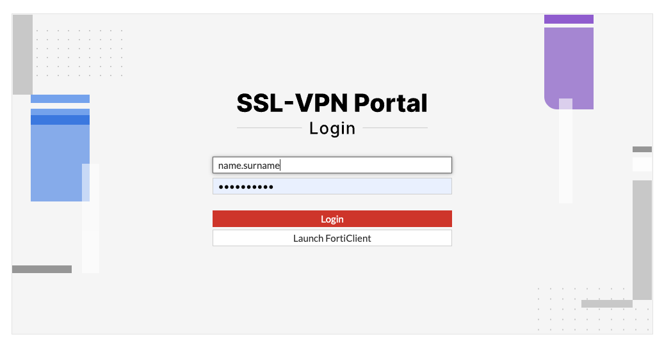

Step 2: Once logged into the web page that appears next click on the “Download FortiClient” button and select the Windows version and proceed with the installation after the download is complete.

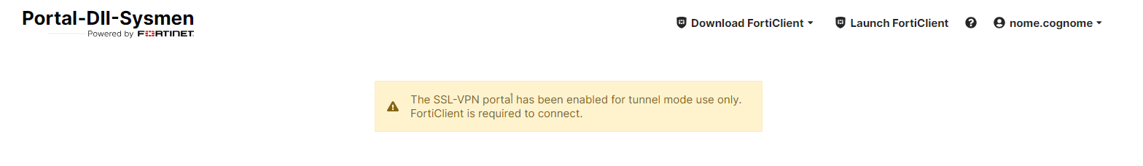

Step 3: Start the “FortiClient VPN” program and proceed with the configuration:

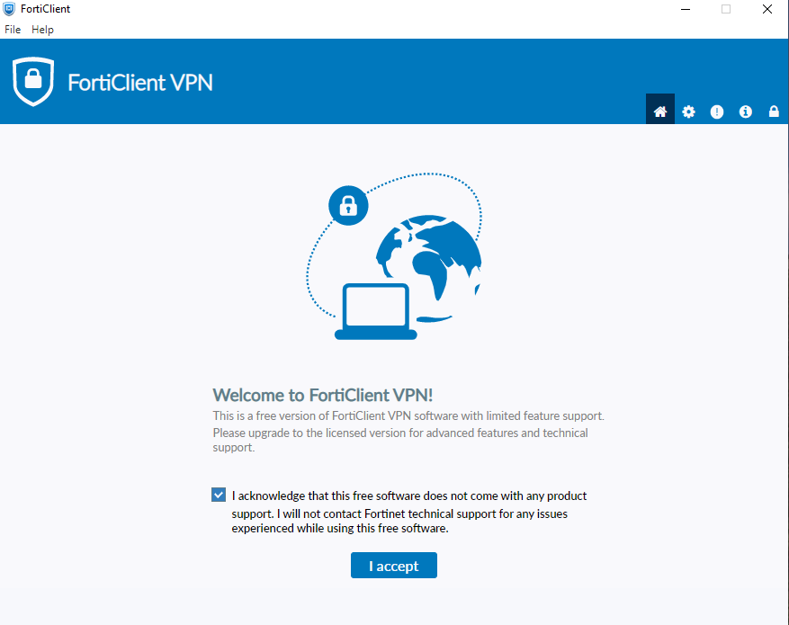

click: “I accept”

Step 4: Configure VPN

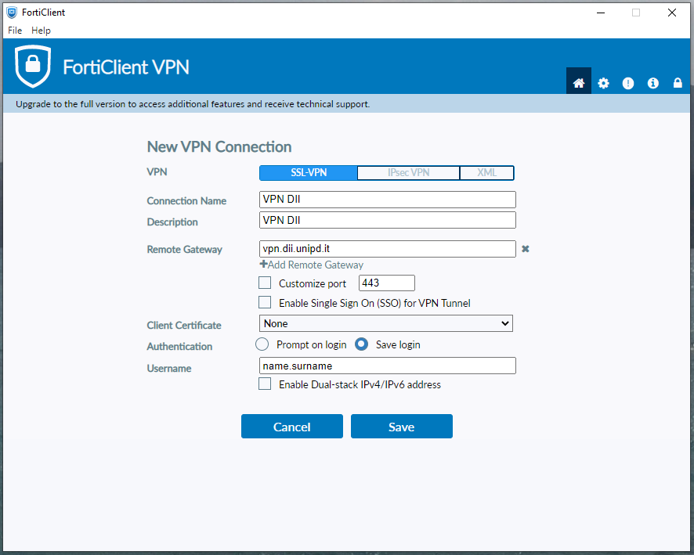

enter the username provided and click **Save**.

2.1.2 Connection

Step 1: Steps to be taken after configuration and with each subsequent connection after successful completion of configuration.

1. Enter the password that arrived via email with the subject line: “Account activation for VPN”
2. Press “Connect”

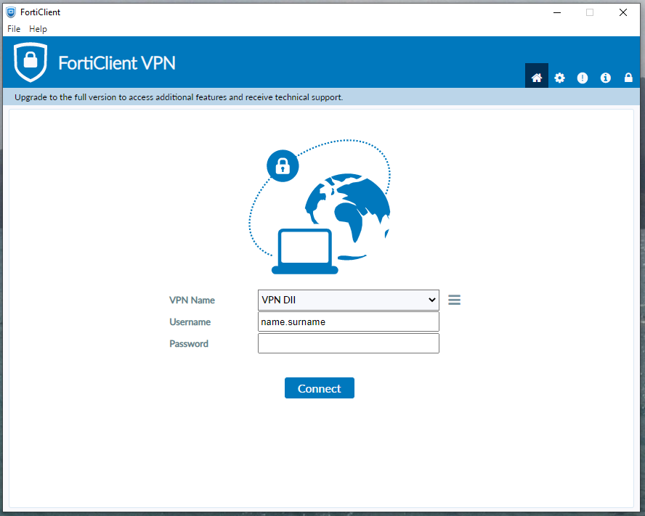

If everything was successful, the following screen will appear:

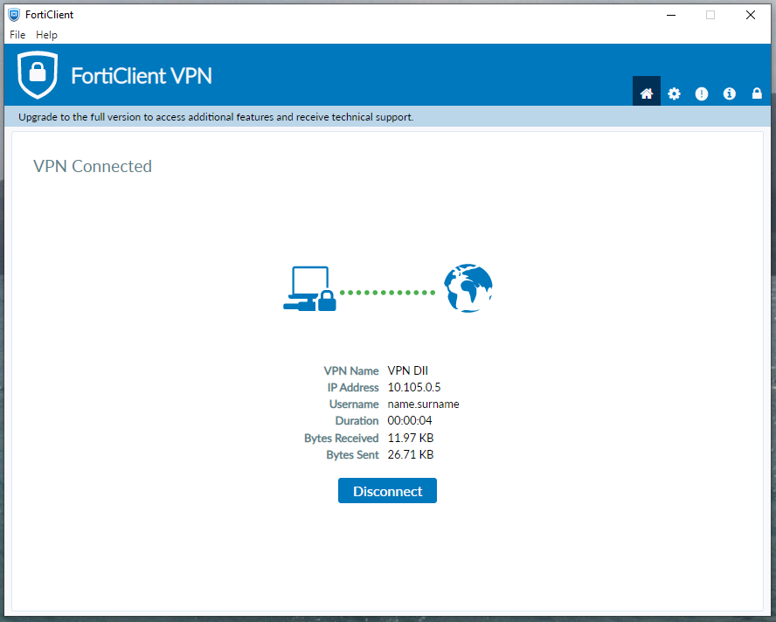

Step 2. From this point on, IT services can be accessed.

To access your workstation from a Windows-based computer/office PC, you need to use the “Remote Desktop Connection” app always available in Windows-based PCs.

Go to: “Start,” search for and run the app: “Remote Desktop Connection”

and configure it as follows:

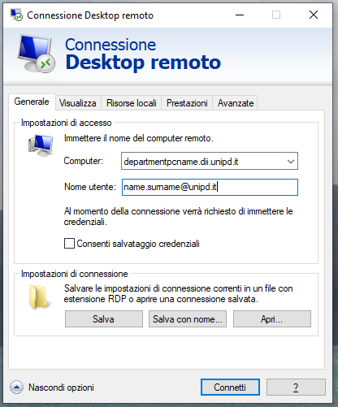

The “**departmentpcname.dii.unipd.it**” is the “**Device Name**” found by right-clicking on: menu Start > Settings > System **and must be followed by .dii.unipd.it**.

For future reference, you can save this configuration by clicking on “Save As/Save As.”

Once you press the Connect button simply enter your SSO password. (N.B. SSO credentials are not saved).

Step 3. When finished, close the Remote Desktop Connection application and click on Disconnect in the Forticlient application.

### 2.2 macOS

2.2.1 Configuration

**Attention:**

**Steps 1 to 4 of the configuration should be done only the first time.**

Step 1: Open a browser of your choice and connect to the web page: <https://vpn.dii.unipd.it>, enter the credentials provided by email (the sender appears to be noreply@accessi.dii.unipd.it)



Step 2: Once logged into the web page that appears next click on the “Download FortiClient” button and select the macOS version and proceed with the installation after the download is complete.





Step 3: Start the program “FortiClient VPN” click on “I accept” and then proceed with the configuration:



and click **Save**.

Step 4: To connect to the office PC download from the Apple Store the app: Microsoft Remote Desktop found at the following link:

<https://apps.apple.com/it/app/microsoft-remote-desktop/id1295203466?mt=12>

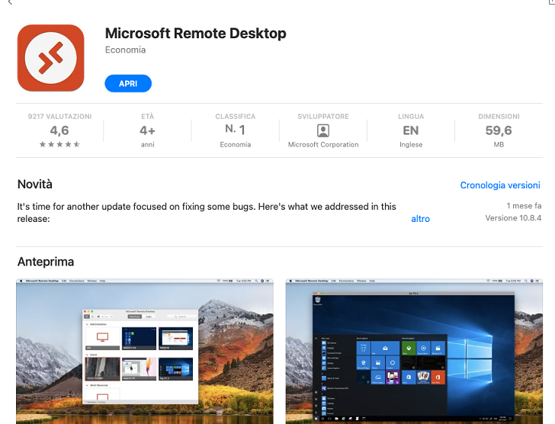

and start it.

## 

Step 5: Save credential SSO/DII

In the top bar, select Microsoft Remote Desktop -> Preferences and select the “User Accounts” tab and finally on the +.

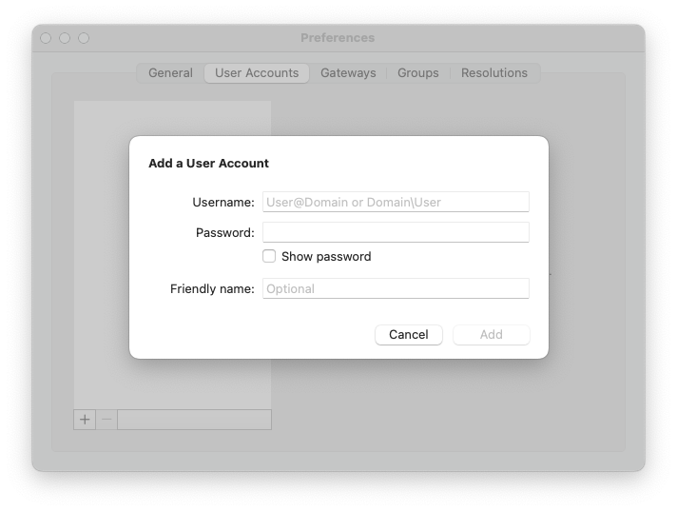

and configure.

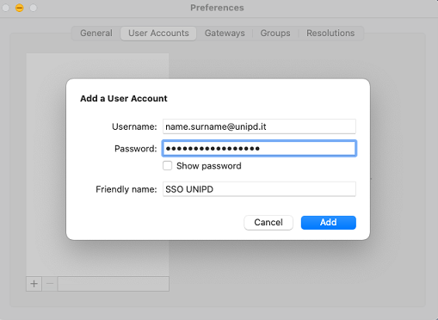

and then click add.

Step 6: RDP

Now go back into the app and click on the blue “Add PC” button:

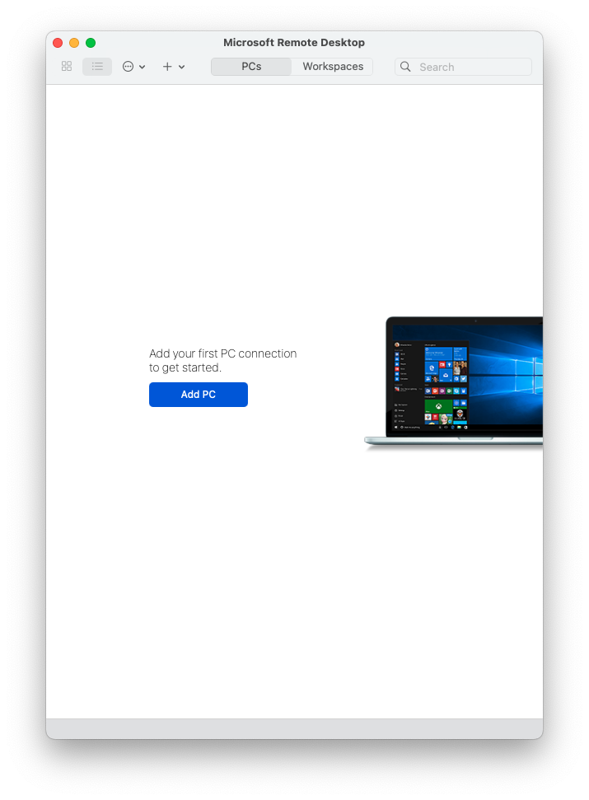

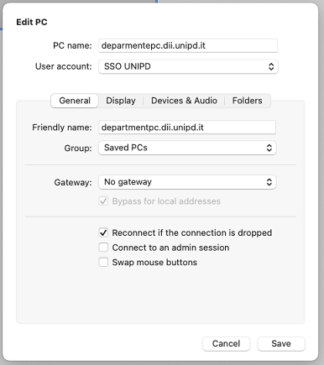

and click Add.

The “**departmentpcname.dii.unipd.it**” is the “**Device Name**” found by right-clicking on: menu Start > Settings > System **and must be followed by .dii.unipd.it**.

For future reference, you can save this configuration by clicking on “Save As/Save As.”

An icon appears as in the picture:

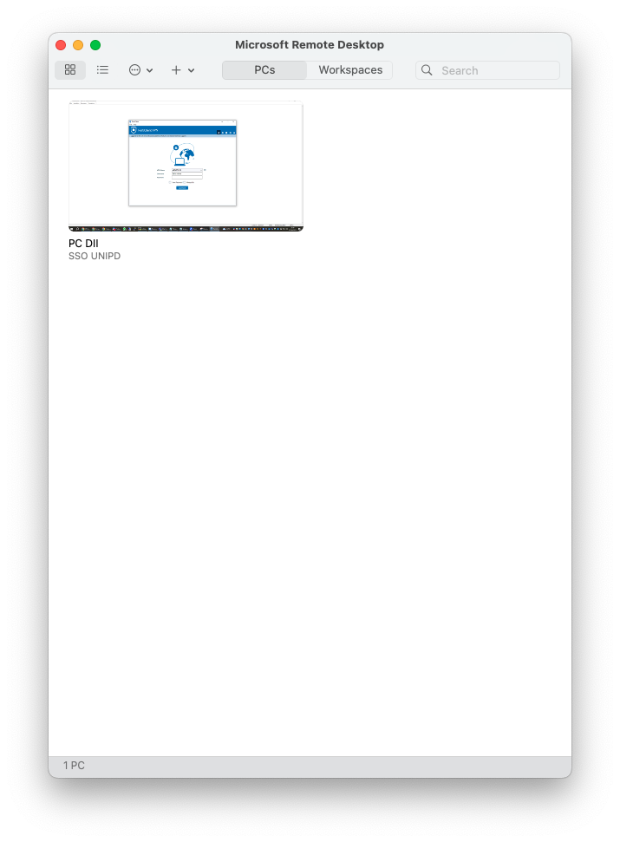

2.2.2 Connection

Steps to be taken after configuration and with each subsequent connection after successful completion of configuration.

Step 1: Connect





Step 2: Start “Microsoft remote desktop”

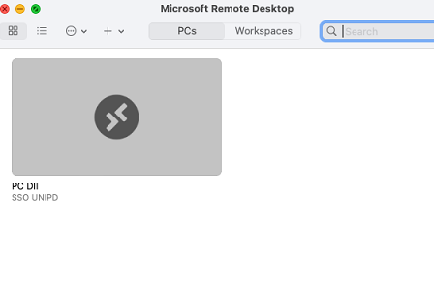

Double click on the PC DII / SSO UNIPD icon to connect to the pc.

## **3. Password change**

Credentials for VPN access for security reasons **must be changed every 180 days**. Warning emails are sent for the expiring password.

### 3.1 Password change

### 

Step 1: Connect to the vpn and then open any browser and connect to the web page: <https://usrpwd.dii.unipd.it/>. The following web interface will be displayed:

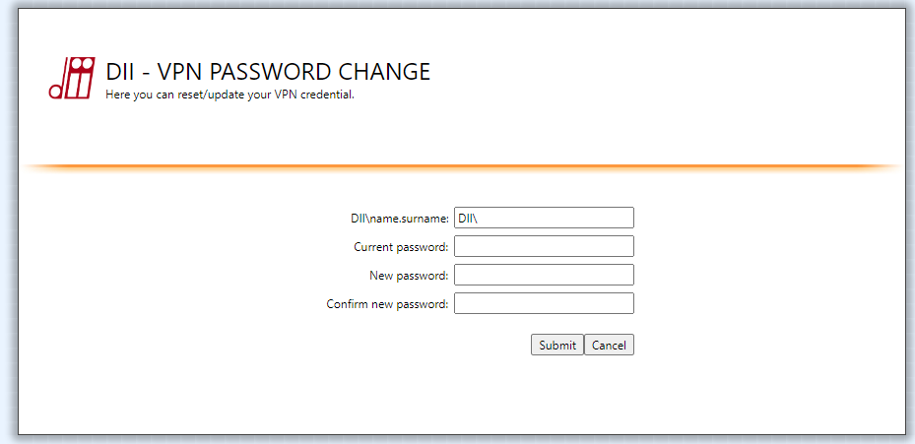

At this point it is necessary to fill in the fields like this:

* DII\name.surname
* the current password[3]
* New password and Confirm new password: enter the new password twice[4]

and finally click on the “Submit” button. If the operation was successful you will get a message like:

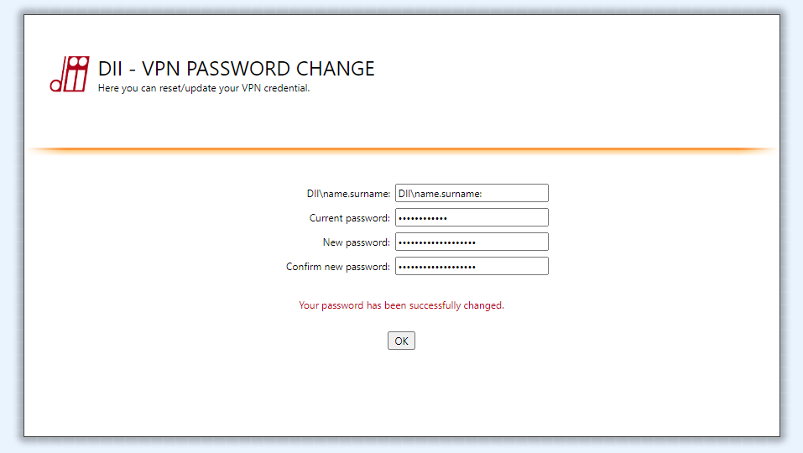

At this point you can proceed with the connection with your new credentials.

## **4 HELPDESK**

For assistance open a ticket <https://www.dii.unipd.it/helpdesk> on the SERVIZI INFORMATICI::1 Account e servizi di rete.

1. It’s possible to install a linux version from the [official](https://www.fortinet.com/support/product-downloads#vpn) site and [remmina](https://remmina.org/) as RDP client
2. FILE SENDER GARR: https://filesender.garr.it/
3. If you don’t remember the password, request a new password through helpdesk.
4. The password must contain uppercase letters, lowercase letters, at least one number and at least one symbol and must be at least 12 characters long